**OVERVIEW**

This report provides an overview of the internship experience focused on Python and web development programming languages. The internship took place over one month at Nxtlogic Software Solutions, offering comprehensive exposure to real-world applications and development practices in Python and web development. The objective was to enhance practical programming skills, understand the development lifecycle, and contribute to ongoing projects. This internship offers a unique opportunity to gain hands-on experience with cutting-edge technologies and frameworks.

**OBJECTIVE**

**Python:**

At Nxtlogic Software Solutions, the objective of using Python is multifaceted and aligned with delivering innovative, scalable, and efficient software solutions across various domains. Here’s an overview of the objectives of Python usage at Nxtlogic:

1. Versatility and Adaptability:

Python is chosen for its versatility, allowing Nxtlogic to develop diverse applications ranging from web development and data analysis to automation scripts and machine learning models. The goal is to leverage Python’s adaptability across different platforms and technologies, ensuring compatibility and ease of integration with existing systems.

2. Web Development Excellence:

Python frameworks like Django and Flask are utilized to build robust and scalable web applications. The objective is to deliver feature-rich web solutions that meet client requirements for functionality, performance, and security. Emphasis is placed on leveraging Python’s capabilities to streamline development processes, enhance code maintainability, and ensure rapid deployment of web applications.

3. Data Science and Machine Learning Innovation:

Python’s extensive ecosystem of libraries such as NumPy, Pandas, and scikit-learn is employed to drive innovation in data science and machine learning projects.The objective is to harness Python’s capabilities for data manipulation, statistical analysis, and machine learning model development to derive valuable insights and predictive capabilities for clients.

4. Automation and Efficiency:

Python’s simplicity and readability make it ideal for automation tasks and scripting. Nxtlogic aims to develop efficient automation solutions that optimize workflows, reduce manual effort, and enhance productivity.The objective is to leverage Python’s scripting capabilities to automate routine tasks, manage infrastructure, and integrate with other systems seamlessly.

5. Security and Reliability:

Python’s robustness and extensive libraries for security (e.g., cryptography) are leveraged to ensure the development of secure and reliable software solutions.The objective is to implement industry best practices for secure coding, encryption, authentication, and authorization, mitigating potential vulnerabilities and ensuring data protection.

6. Consulting and Custom Solutions:

Nxtlogic aims to provide expert consulting services leveraging Python’s capabilities. The objective is to understand client needs comprehensively, offer tailored solutions, and deliver value-added services that align with business objectives.This includes providing strategic guidance, architecture design, and implementation of custom Python solutions to address specific client challenges and opportunities.

In summary, Python at Nxtlogic Software Solutions is used with the objective of delivering innovative, scalable, and efficient software solutions across web development, data science, automation, and beyond. The focus is on leveraging Python’s versatility, robustness, and extensive ecosystem to meet client needs effectively and exceed expectations in software development.

**Basic knowledge on the python code:**

**APIs (Application Programming Interfaces)**

* **OpenWeatherMap API**: The code uses an API to fetch weather data for a specific city. APIs allow applications to communicate with each other; in this case, the API provides weather information in JSON format.

**2. Libraries and Modules**

* **requests**: A Python library used to send HTTP requests. Here, it's used to fetch data from the OpenWeatherMap API.
* **time**: A standard Python library that includes functions for time manipulation. It's used to convert Unix timestamps to human-readable format.
* **tkinter**: The standard GUI toolkit for Python. It provides tools to create graphical interfaces.

**3. GUI Elements with Tkinter**

* **Tkinter Window (canvas)**: The main application window created using Tk().
* **Text Field (Entry)**: An input field where the user can type the name of a city.
* **Labels (Label)**: Text display elements used to show the weather information.
* **Font Styles**: Defined using tuples, they set the font type, size, and weight for text elements.

**4. Event Handling**

* **Binding Events**: The code binds the <Return> event (pressing the Enter key) to the getWeather function, so when the user presses Enter after typing a city name, the function is called.

**5. Data Processing**

* **Fetching Data**: The getWeather function fetches weather data for the entered city using the API.
* **JSON Parsing**: The data from the API is in JSON format, which is parsed to extract specific weather details such as temperature, weather condition, pressure, humidity, wind speed, sunrise, and sunset times.
* **Temperature Conversion**: The temperature data from the API is in Kelvin and is converted to Celsius.
* **Time Formatting**: The sunrise and sunset times are given in Unix timestamp format and are converted to a human-readable format (HH:MM

).

**6. Displaying Data**

* The weather information is formatted and displayed on the Tkinter window using labels.

**Web Development:**

At Nxtlogic Software Solutions, the objectives of web development are centered around delivering high-quality, scalable, and innovative web solutions that meet the needs of clients across various industries. Here’s an overview of the objectives of web development at Nxtlogic:

1. Client-Centric Approach:

The primary objective is to understand and align with the specific requirements and business goals of each client. Nxtlogic aims to deliver customized web solutions that address unique challenges and maximize business opportunities.

2. Innovation and Technology:

Nxtlogic strives to leverage cutting-edge technologies and frameworks in web development to ensure that solutions are modern, efficient, and future-proof.The objective is to continuously innovate and explore new technologies that can enhance user experience, performance, and security of web applications.

3. Scalability and Performance:

Scalability is a key objective in web development at Nxtlogic. The goal is to design and build web applications that can handle increasing user loads and data volumes without compromising performance.Techniques such as efficient database design, caching strategies, and use of scalable infrastructure (e.g., cloud services, containerization) are employed to achieve this objective.

4. Security and Reliability:

Ensuring the security and reliability of web applications is a paramount objective. Nxtlogic implements robust security measures throughout the development lifecycle to protect against vulnerabilities and ensure data integrity.Best practices in authentication, authorization, data encryption, and secure coding are applied to mitigate risks and safeguard sensitive information.

**SYSTEM DESIGN**

### ****Purpose****

The purpose of this system is to provide a simple weather application that allows users to retrieve and display current weather information for a specified city using the OpenWeatherMap API. The application is built using Python and the Tkinter library for the graphical user interface (GUI).

### ****System Components****

#### a. **Frontend**

* **Tkinter GUI**:
  + **Main Window (canvas)**: The primary interface that houses all other elements.
  + **Text Field (textfield)**: Input field where users enter the city name.
  + **Labels (label1 and label2)**: Display areas for weather information such as temperature, weather condition, humidity, etc.

#### b. **Backend**

* **Weather Data Fetching (requests)**:
  + **API Endpoint**: Uses Open Weather Map API to fetch weather data.
  + **Data Processing**: Parses JSON data from the API response to extract relevant weather details.
  + **Error Handling**: (Not explicitly covered in the provided code but should be included for robustness, such as handling invalid city names or network issues.)

#### c. **External Services**

* **OpenWeatherMap API**: Provides weather data based on the city name provided by the user. Requires an API key for access.

### ****Data Flow****

1. **User Input**:
   * The user enters a city name into the text field.
   * The user presses the Enter key, triggering the get Weather function.
2. **API Request**:
   * The getWeather function constructs an API request URL using the provided city name and the API key.
   * The requests library sends a GET request to the Open Weather Map API.
3. **Data Processing**:
   * The API returns weather data in JSON format.
   * The application extracts necessary information (e.g., temperature, weather conditions, wind speed, etc.).
   * The temperature data is converted from Kelvin to Celsius.
4. **Display Data**:
   * The extracted and processed data is formatted and displayed in the labels (label1 and label2) on the Tkinter GUI.

### ****User Interface Design****

* **Input Section**: A single text field for city input.
* **Output Section**: Two labels for displaying weather condition, temperature, and additional details like humidity, wind speed, etc.

### ****Error Handling and Edge Cases****

* **Invalid City Input**: The system should handle cases where the city is not found or the input is invalid.
* **API Key Issues**: Handle cases where the API key is invalid or the request limit is exceeded.
* **Network Errors**: Handle scenarios where the user’s internet connection is unavailable or unstable.

### ****Future Enhancements****

* **Improved UI**: Adding more graphical elements, such as icons representing weather conditions.
* **Additional Features**: Including forecast data, different units (Fahrenheit/Celsius), and more detailed weather statistics.
* **Localization**: Support for multiple languages and localization of units and time formats.

**SETTING UP THE DEVELOPMENT ENVIRONMENT**

### Install Python

To start, ensure that Python is installed on your machine, as the weather application is developed in Python. It is recommended to use Python version 3.6 or higher. You can check if Python is installed by opening a terminal or command prompt and typing python --version. If Python is not installed, you can download and install it from the [official Python website](https://www.python.org/downloads/).

### Set Up a Virtual Environment

Setting up a virtual environment is a best practice in Python development, as it helps manage dependencies and avoid conflicts between different projects. To create a virtual environment, use the command python -m venv weather_app_env, where weather_app_env is the name of the virtual environment. After creating the environment, activate it by running weather_app_env\Scripts\activate on Windows, or source weather_app_env/bin/activate on macOS and Linux. Once activated, your terminal prompt should indicate that you are in the virtual environment.

### Install Required Packages

Next, install the required external libraries. If a requirements.txt file is provided, use pip install -r requirements.txt to install all necessary packages. If no such file is provided, you can manually install the required packages, such as requests, using the command pip install requests. Note that Tkinter is usually included with Python's standard library, so a separate installation may not be necessary.

### Set Up API Access

The application uses the OpenWeatherMap API, which requires an API key. To obtain an API key, register at OpenWeatherMap. Once you have the API key, replace the placeholder your_api_key_here in the code with your actual API key. It is recommended to use environment variables to store sensitive information like API keys. For instance, on Windows, you can set an environment variable with set OPENWEATHER_API_KEY=your_api_key_here, and on macOS and Linux, use export OPENWEATHER_API_KEY=your_api_key_here.

### Running the Application

To run the application, ensure that you are in the virtual environment. Navigate to the directory containing your Python script and execute it by running python your_script_name.py.

### Development Tools (Optional)

For a better development experience, consider using an Integrated Development Environment (IDE) like PyCharm, Visual Studio Code, or Sublime Text. These tools offer features such as syntax highlighting, debugging, and version control integration. Additionally, using Git for version control is recommended. You can initialize a Git repository in your project directory with git init and commit your changes with git add . and git commit -m "Initial commit".

### Testing and Debugging

Testing and debugging are critical processes in the development of the weather application, ensuring it functions correctly and meets user expectations.Testing begins with unit testing, which focuses on verifying that individual components or functions of the application perform as intended when isolated from the rest of the system. For example, unit tests can be written to validate the getWeather function's ability to correctly process user inputs and return the expected weather data. This might involve testing whether temperature conversions from Kelvin to Celsius are accurate or if the function can correctly interpret and display various weather conditions from the API response. Utilizing testing frameworks such as unittest or pytest, developers can automate these tests, making it easier to identify and fix errors in the code.Integration testing follows, where the interaction between different parts of the application is tested. This ensures that components, such as the GUI elements and the data retrieval logic, work seamlessly together. For instance, integration tests can verify that user inputs are correctly passed to the API request function and that the resulting data is accurately displayed on the interface.

**Weather Detection basics**

Weather detection relies on several key elements, which are measured to describe and predict weather conditions:

* **Temperature**: The measure of heat in the atmosphere, usually reported in Celsius or Fahrenheit. Temperature is measured using thermometers.
* **Humidity**: The amount of moisture in the air. It can be expressed as absolute humidity (grams of water vapor per cubic meter of air) or relative humidity (percentage of moisture relative to the maximum amount air can hold at that temperature). Humidity is measured using hygrometers.
* **Pressure**: The weight of the air above a given point. Atmospheric pressure can indicate changes in weather, with high pressure generally associated with fair weather and low pressure linked to storms. It is measured using barometers.
* **Wind**: The movement of air from high-pressure areas to low-pressure areas. Wind speed and direction are crucial for weather forecasting. Anemometers measure wind speed, and wind vanes or other instruments measure direction.
* **Precipitation**: Any form of water, liquid or solid, that falls from the sky, including rain, snow, sleet, and hail. Precipitation is measured using rain gauges for liquid precipitation and snow gauges for solid precipitation.
* **Cloud Cover**: The fraction of the sky covered by clouds, which affects the amount of sunlight reaching the Earth's surface. This is observed and reported using visual observations or satellite data.
* **Visibility**: The distance one can clearly see, which can be affected by fog, rain, or other atmospheric conditions. Visibility is measured using instruments like visibility sensors or through visual estimation.

**Measurement Instruments**

* **Thermometer**: Measures temperature. Types include mercury, alcohol, and digital thermometers.
* **Hygrometer**: Measures humidity. Common types are psychrometers (using dry and wet bulb temperatures) and capacitive or resistive humidity sensors.
* **Barometer**: Measures atmospheric pressure. Types include mercury, aneroid, and digital barometers.
* **Anemometer**: Measures wind speed. Types include cup, vane, and ultrasonic anemometers.
* **Rain Gauge**: Measures precipitation. Types include standard, tipping bucket, and weighing rain gauges.
* **Cloud Sensor**: Measures cloud cover, often using visual or infrared techniques.
* **Visibility Sensor**: Measures how far one can see, using techniques such as laser or infrared beams.

**Data Collection Methods**

* **Weather Stations**: Installations equipped with various sensors and instruments to continuously monitor and record weather conditions.
* **Weather Satellites**: Orbit the Earth and provide comprehensive data on weather patterns, cloud cover, and other atmospheric conditions.
* **Weather Radars**: Emit radio waves and analyze the reflected signals to detect precipitation, its intensity, and movement.
* **Weather Balloons**: Carry instruments (radiosondes) into the atmosphere to collect data on temperature, humidity, and pressure at different altitudes.

**Weather Data Interpretation**

* **Current Weather Conditions**: Describe the present state of weather elements (e.g., "It is 25°C with 60% humidity and light rain").
* **Weather Forecasting**: Involves using current and historical weather data, computer models, and statistical methods to predict future weather conditions. Forecasts can range from short-term (daily) to long-term (seasonal).
* **Weather Maps**: Visual representations of weather data, such as temperature, pressure systems, and precipitation patterns. These are used to understand and predict weather trends.

**Weather APIs**

* **Weather APIs**: Allow developers to access weather data from various sources programmatically. Examples include the OpenWeatherMap API, Weather API, and AccuWeather API. These APIs provide current weather conditions, forecasts, and historical data through web requests.

**Weather Alerts and Warnings**

Weather detection systems also issue alerts and warnings for severe weather conditions, such as storms, hurricanes, and extreme temperatures, to help people prepare and stay safe.

**Importance of Weather app**

The importance of a weather app extends beyond simply providing current weather conditions. Weather apps play a crucial role in various aspects of daily life, safety, and decision-making. Here’s a detailed look at why weather apps are important:

### ****Personal Safety and Preparedness****

Weather apps provide real-time updates on weather conditions, including severe weather warnings such as thunderstorms, hurricanes, or blizzards. This information allows individuals to take necessary precautions, such as seeking shelter or postponing travel plans, thereby enhancing personal safety.

### ****Travel Planning****

When planning trips, whether for business or leisure, having access to accurate weather forecasts is essential. Weather apps help travelers anticipate conditions at their destination, plan appropriate clothing, and adjust travel arrangements to avoid bad weather.

### ****Outdoor Activities****

For those who engage in outdoor activities such as hiking, camping, or sports, weather apps provide critical information about weather conditions. This helps in making informed decisions about when and where to engage in outdoor activities, ensuring a safer and more enjoyable experience.

### ****Health and Well-being****

Weather conditions can significantly affect health. For instance, extreme heat or cold can impact individuals with certain health conditions. Weather apps can provide alerts for heatwaves or cold snaps, enabling individuals to take necessary precautions to protect their health.

### ****Agriculture and Farming****

Farmers and agricultural professionals rely on weather forecasts for planting, harvesting, and managing crops. Accurate weather data helps them make informed decisions about irrigation, fertilization, and pest control, which can lead to better crop yields and reduced losses.

### ****Emergency Response****

In times of natural disasters, weather apps are a vital tool for emergency response teams. They provide updated information on weather conditions, which is crucial for coordinating rescue operations, distributing aid, and managing evacuations effectively.

### ****Energy Management****

Weather conditions impact energy consumption patterns. For example, cold weather increases heating demands, while hot weather increases cooling demands. Energy companies use weather data to forecast demand and manage energy supply efficiently. Consumers can also use weather apps to adjust their energy usage based on forecasts.

### ****Daily Convenience****

Weather apps offer convenience in daily life by providing information on temperature, precipitation, and other weather-related details. This helps individuals plan their daily activities, such as deciding when to do laundry, whether to carry an umbrella, or when to schedule outdoor events.

### ****Economic Impact****

Weather apps contribute to various sectors of the economy. For instance, businesses involved in retail, logistics, and transportation use weather data to optimize operations and reduce disruptions. Accurate weather forecasting can lead to cost savings and improved efficiency in these industries.

### ****Climate Awareness****

Weather apps also play a role in raising awareness about climate change and environmental issues. By providing long-term weather patterns and climate data, these apps can help users understand trends and contribute to discussions about environmental conservation.

### ****Technology Integration****

Modern weather apps often integrate with other technologies, such as smart home systems, to provide automated responses based on weather conditions. For example, smart thermostats can adjust heating or cooling based on weather forecasts provided by the app.

**Implementation**

The weather application was developed to provide users with real-time weather information using a graphical user interface (GUI) created with Tkinter, along with data fetched from the OpenWeatherMap API.

**The GUI of the application is constructed using Tkinter, a standard Python library for creating graphical interfaces.** The main window is set to a size of 600x500 pixels and is titled "Weather App." Within this window, a text entry field is created, allowing users to input the name of a city. This field is styled with a bold font for better visibility and is configured to automatically focus when the application starts.

Two labels are employed to display the weather data. The first label shows the current weather condition and temperature, while the second label presents additional details such as the maximum and minimum temperatures, atmospheric pressure, humidity, wind speed, and the times for sunrise and sunset. These labels use distinct font styles to differentiate between the types of information presented.

**The core functionality of the application is managed by the getWeather function.** This function begins by retrieving the city name entered by the user and constructs an API request URL for OpenWeatherMap. It sends an HTTP GET request to this URL using the requests library and processes the JSON response.

The function extracts various pieces of weather data from the response. It captures the main weather condition, converts temperature readings from Kelvin to Celsius, and retrieves atmospheric pressure, humidity, wind speed, and sunrise/sunset times. These times are converted from Unix time format to a human-readable format.

**The extracted weather information is then formatted into readable strings and displayed on the application interface.** The first label updates to show the current weather condition and temperature, while the second label is updated with additional details including temperature ranges, pressure, humidity, wind speed, and sunrise/sunset times.

**User interaction is facilitated by binding the Enter key to the getWeather function.** When users input a city name and press Enter, the function is triggered to fetch and display the corresponding weather data.

**While the current implementation does not include explicit error handling, it is crucial to incorporate mechanisms for managing potential issues.** This includes handling scenarios where the API request might fail or where users might enter invalid city names, ensuring that the application provides appropriate error messages or default responses.

**The application is kept active and responsive through the Tkinter event loop, initiated by calling canvas.mainloop().** This loop allows the application to continuously run and interact with users.

**Algorithm**

**Initialize Application:** Start by importing the necessary libraries: requests, time, and tkinter. Then, create the main application window using Tkinter.

**Create GUI Components:** Define the font styles for the GUI. Create a text field (textfield) where users can input the city name. Create labels (label1 and label2) to display the weather information.

**Event Binding:** Bind the Enter key (<Return>) to the getWeather function, so that when the user presses Enter after typing the city name, the function is triggered.

**Function: getWeather:** This function starts by retrieving the city name from the text field. It then constructs an API request URL using the provided city name and the API key. The function sends a GET request to the OpenWeatherMap API and parses the JSON response. From the response, it extracts relevant weather data, including the weather condition, temperature (converted from Kelvin to Celsius), minimum and maximum temperatures, atmospheric pressure, humidity, wind speed, and sunrise and sunset times (converted from Unix timestamp to HH:MM

format). The extracted data is then formatted into a readable format, and the labels in the GUI are updated with this information.

**Display GUI:** Call the mainloop() method on the Tkinter window to start the application and keep it running, allowing for user interaction.

**Error Handling (Optional):** Include handling for cases where the API request fails or returns an error, displaying an error message to the user. Also, if the city name is invalid, notify the user to enter a valid city name.

**Code**

import tkinter as tk

import requests

import time

def getWeather(event=None):

city = textfield.get()

api = "http://api.openweathermap.org/data/2.5/weather?q=" + city + "&appid=YOUR_API_KEY"

json_data = requests.get(api).json()

condition = json_data['weather'][0]['main']

temp = int(json_data['main']['temp'] - 273.15)

min_temp = int(json_data['main']['temp_min'] - 273.15)

max_temp = int(json_data['main']['temp_max'] - 273.15)

pressure = json_data['main']['pressure']

humidity = json_data['main']['humidity']

wind = json_data['wind']['speed']

sunrise = time.strftime('%I:%M:%S', time.gmtime(json_data['sys']['sunrise'] - 21600))

sunset = time.strftime('%I:%M:%S', time.gmtime(json_data['sys']['sunset'] - 21600))

final_info = condition + "\n" + str(temp) + "°C"

final_data = "\n".join([

"Max Temp: " + str(max_temp) + "°C",

"Min Temp: " + str(min_temp) + "°C",

"Pressure: " + str(pressure) + " hPa",

"Humidity: " + str(humidity) + "%",

"Wind Speed: " + str(wind) + " m/s",

"Sunrise: " + sunrise,

"Sunset: " + sunset,

])

label1.config(text=final_info)

label2.config(text=final_data)

canvas = tk.Tk()

canvas.geometry("600x500")

canvas.title("Weather App")

f = ("poppins", 15, "bold")

t = ("poppins", 35, "bold")

textfield = tk.Entry(canvas, font=t)

textfield.pack(pady=20)

textfield.focus()

textfield.bind("<Return>", getWeather)

label1 = tk.Label(canvas, font=t)

label1.pack()

label2 = tk.Label(canvas, font=f)

label2.pack()

canvas.mainloop()

**Screenshots of the code**

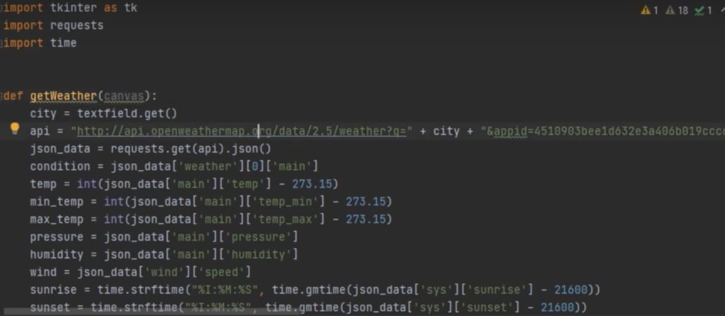

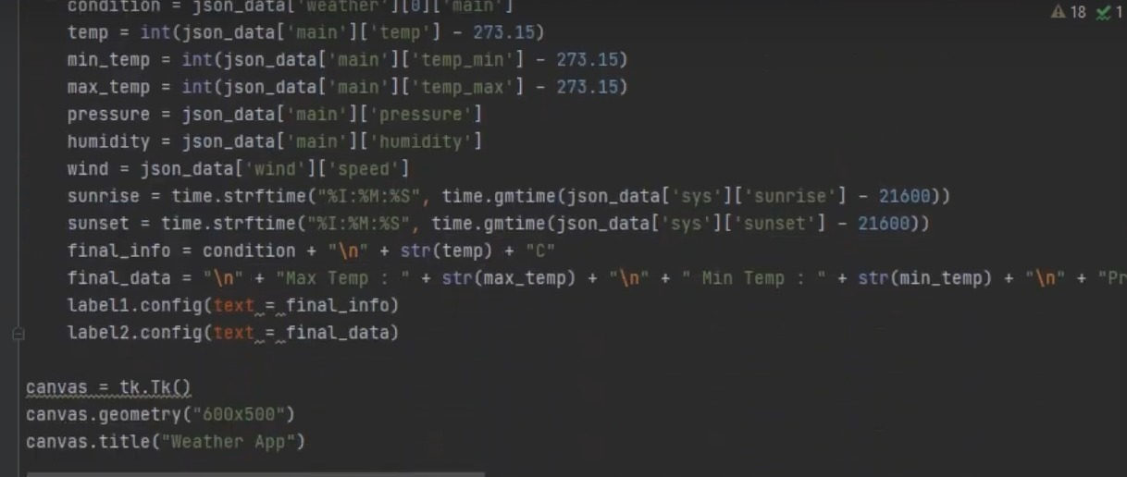

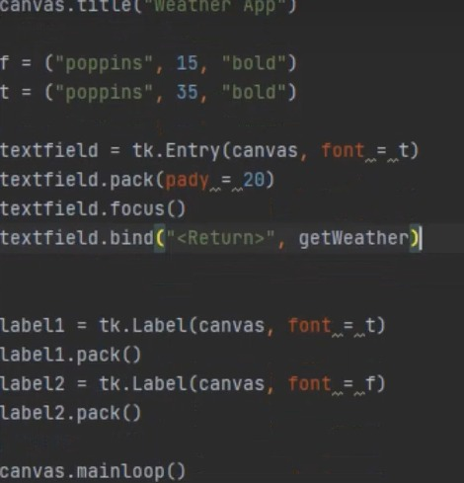

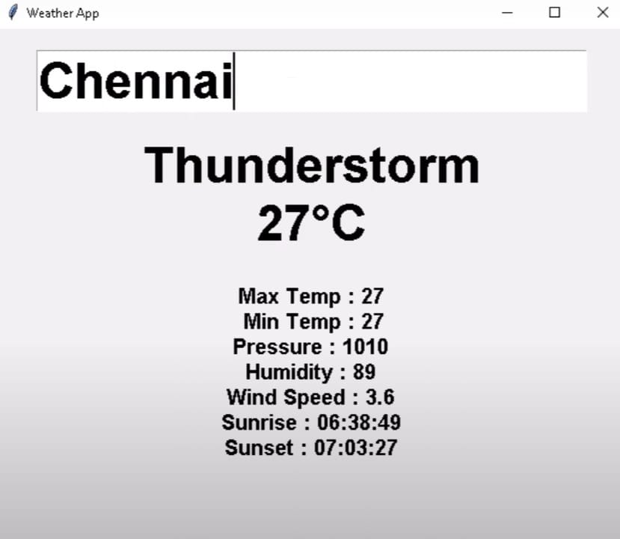**Screenshots of the implementation**

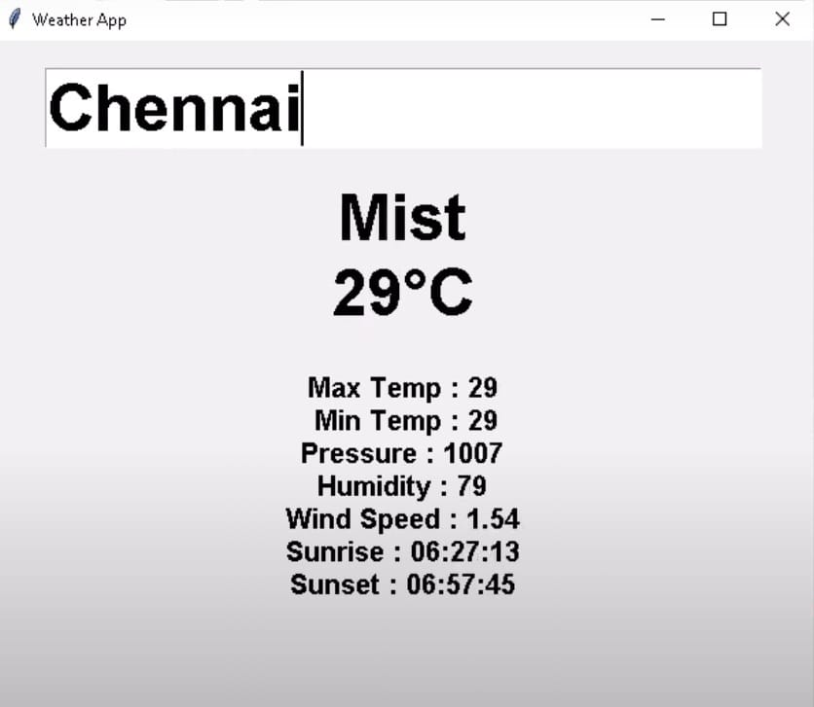

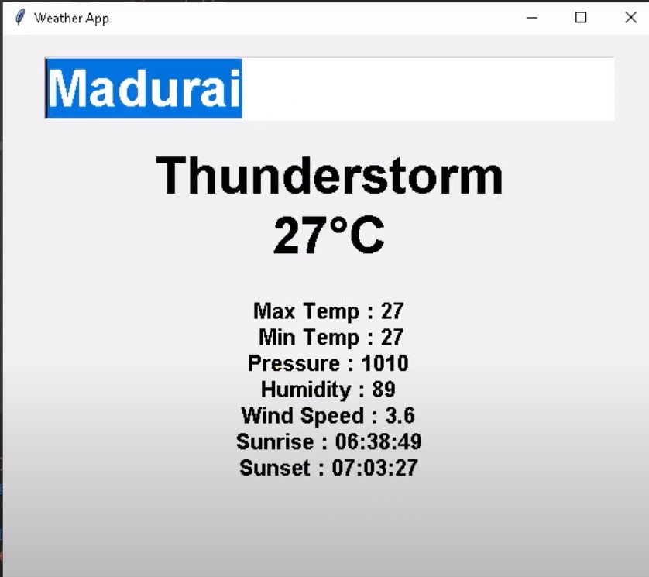

**Advanced Topics and Future Work**

**Advanced Data Visualization:**

Currently, the application displays weather data in textual format. Future enhancements could include integrating graphical elements such as charts and graphs to represent temperature trends, humidity levels, and pressure changes over time. Visualizations could also include icons representing different weather conditions (e.g., sunny, rainy, cloudy) to make the data more intuitive and engaging.

**Real-Time Data and Notifications:**

Implementing real-time data updates and notifications could greatly enhance the application's utility. For instance, using WebSocket connections or periodic polling, the application can provide users with the most current weather conditions without requiring manual refreshes. Additionally, incorporating push notifications for severe weather alerts or significant changes in conditions can help users stay informed and safe.

**Integration with Additional APIs:**

While the application currently uses the OpenWeatherMap API, integrating additional data sources can provide more comprehensive weather information. For example, incorporating APIs that provide air quality index data, pollen levels, or UV index can offer users a more holistic view of environmental conditions. This integration can be particularly beneficial for users with specific health concerns, such as allergies or respiratory conditions.

**Localization and Multilingual Support:**

Expanding the application to support multiple languages and localized weather data can make it accessible to a broader audience. This involves translating the interface and data into different languages and adapting units and formats (e.g., temperature in Celsius or Fahrenheit) to suit regional preferences.

**Machine Learning for Weather Prediction:**

Leveraging machine learning algorithms can enhance the application's predictive capabilities. By analyzing historical weather data and current trends, the application can provide more accurate forecasts and even predict potential weather-related hazards. Implementing features like personalized weather forecasts based on user location and preferences can also improve the user experience.

.

**Offline Functionality:**

Adding offline functionality would allow users to access the last retrieved weather data even without an internet connection. This feature can be useful for travelers or individuals in areas with intermittent connectivity. Implementing this feature involves caching data locally and ensuring that the app can operate in a limited capacity when offline.

**Community and Social Features:**

Integrating social features can increase user engagement. For example, users could share weather conditions or forecasts on social media, or the application could include a community forum for users to discuss weather-related topics. Additionally, features like crowd-sourced weather reports can provide real-time updates from users on the ground.

**Conclusion**

The weather application developed provides a practical tool for accessing real-time weather data through a user-friendly interface. By leveraging the OpenWeatherMap API, users can easily obtain current weather conditions, including temperature, humidity, pressure, wind speed, and more, simply by entering a city name. The use of the Tkinter library for the graphical interface ensures that the application is accessible and straightforward to use. Moving forward, there are numerous opportunities for enhancing the application. These include improving data visualization, incorporating real-time updates and notifications, expanding the range of data sources, and enhancing the user interface. Implementing more robust error handling, ensuring data privacy and security, and exploring the integration of machine learning for predictive analytics are also potential areas for future work.In conclusion, while the weather application offers a solid foundation for accessing weather data, addressing its current limitations and exploring advanced features will significantly enhance its value and usability. This project lays the groundwork for a more comprehensive and user-friendly weather app that can cater to a broader audience and provide more detailed and accurate weather insights.

**Limitations**

The user interface of the application is also quite basic, potentially limiting accessibility and usability. Users cannot customize the interface, such as adjusting the color scheme or font size, which could be important for accessibility. The lack of geolocation support requires users to manually enter city names, which is less convenient and may lead to errors if names are misspelled.

The presentation of weather data is static, lacking real-time updates or interactive features. Once the weather data is retrieved, it does not update automatically, requiring users to manually refresh the information. The application also does not include visual aids such as graphs, icons, or maps, which could help users better understand the data.

**References**

**OpenWeatherMap API Documentation**  
The OpenWeatherMap API is used in the application to fetch real-time weather data. Detailed documentation is available at:  
OpenWeatherMap API

**Python Official Documentation**  
The Python language and its libraries, including requests and time, are fundamental to the application's backend functionality. Documentation and best practices can be found at:  
[Python Documentation](https://docs.python.org/3/)

**Tkinter Documentation**  
Tkinter is the library used for creating the graphical user interface in the application. Comprehensive information on Tkinter can be found at:  
[Tkinter Documentation](https://docs.python.org/3/library/tkinter.html)

**Python Testing Frameworks**  
For unit and integration testing, frameworks like unittest and pytest are commonly used. Documentation for these frameworks provides guidelines on writing and running tests:

* [unittest Documentation](https://docs.python.org/3/library/unittest.html)
* pytest Documentation

**Python Logging Module**  
The logging module is used for tracking events and debugging. The official documentation provides details on configuring and using logging in Python:  
[Python Logging](https://docs.python.org/3/library/logging.html)

**Pythonsphere: Tkinter Tutorials and Guides**  
A valuable resource for learning more about building GUIs with Tkinter, including advanced features and best practices:  
Pythonsphere: Tkinter Tutorials

**Python Programming Tutorials and Community Resources**  
Online resources and community forums, such as Stack Overflow, offer a wealth of knowledge and troubleshooting advice for Python programming:  
[Stack Overflow](https://stackoverflow.com/questions/tagged/python)